**Assignment no 14**

1)

#include<stdio.h>

void main()

{

int i,a[5];

for(i=0;i<5;i++)

{

printf("Enter the %d element",i+1);

scanf("%d",&a[i]);

}

printf("The Elements are \n");

for(i=0;i<5;i++)

{

printf("%d\n",a[i]);

}

getch();

}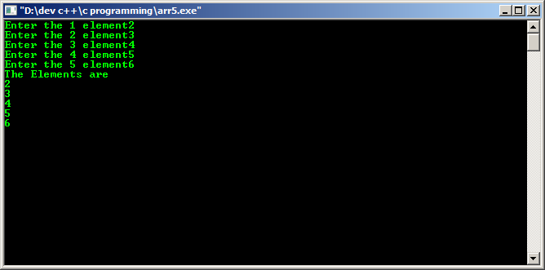

2) #include<stdio.h>

void main()

{

int i,sum=0;

int x[100];

for(i=0;i<5;i++)

{

printf("Enter the %d element",i+1);

scanf("%d",&x[i]);

sum=sum+x[i];

}

printf("\nThe sum of all the elements of an array is %d\n",sum);

getch();

}

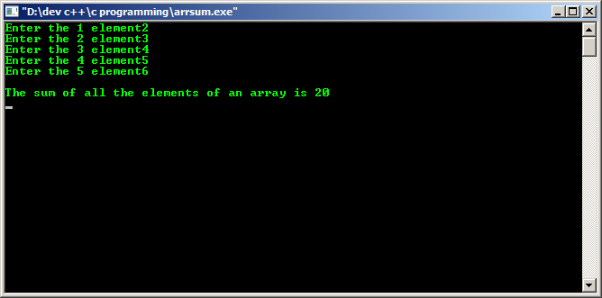

3)

#include<stdio.h>

void main()

{

int a[5],i;

float avg,sum=0;

printf("Entering elements:\n");

for(i=0;i<5;i++)

{

printf("\nEnter the %d element",i+1);

scanf("%d",&a[i]);

}

for(i=0;i<5;i++)

{

sum=sum+a[i];

avg=sum/10;

}

printf("\n the average of the elements are %f\n",avg);

getch();

}

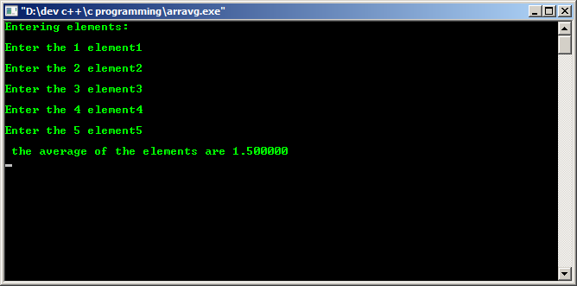

4)

#include<stdio.h>

void main()

{

int i,j;

int a[5],temp;

printf("Entering elements:");

for(i=0;i<5;i++)

{

printf("\nEnter the %d element",i+1);

scanf("%d",&a[i]);

}

for(i=0;i<5;i++)

{

for(j=i+1;j<5;j++)

{

if(a[i]<a[j])

{

temp=a[i];

a[i]=a[j];

a[j]=temp;

}

}

}

printf("Descending Ordered Array is :\n");

for(j=0;j<5;j++)

{

printf("%d\n",a[j]);

}

getch();

}

